VICORI guide to data access
Version 2.0, 23rd September 2021

Background:
The Virtual Cardio-Oncology Research Initiative (VICORI) programme aims to create a quality assured dataset containing linked data from the National Cancer Registration and Analysis Service (NCRAS), managed by Public Health England (PHE) and the six National Cardiovascular disease audits held by the National Institute for Cardiovascular Outcome Research (NICOR). This dataset will be used to investigate differences in treatments and outcomes between patients with cancer, cardiovascular disease, or both. This document outlines the process to access VICORI data for collaborators and other bona fide researchers. If you have any questions, please contact us vicori@le.ac.uk.

VICORI Data Access process:
Researchers can request to access VICORI data by following the processes described below and as outlined in Figure 1.
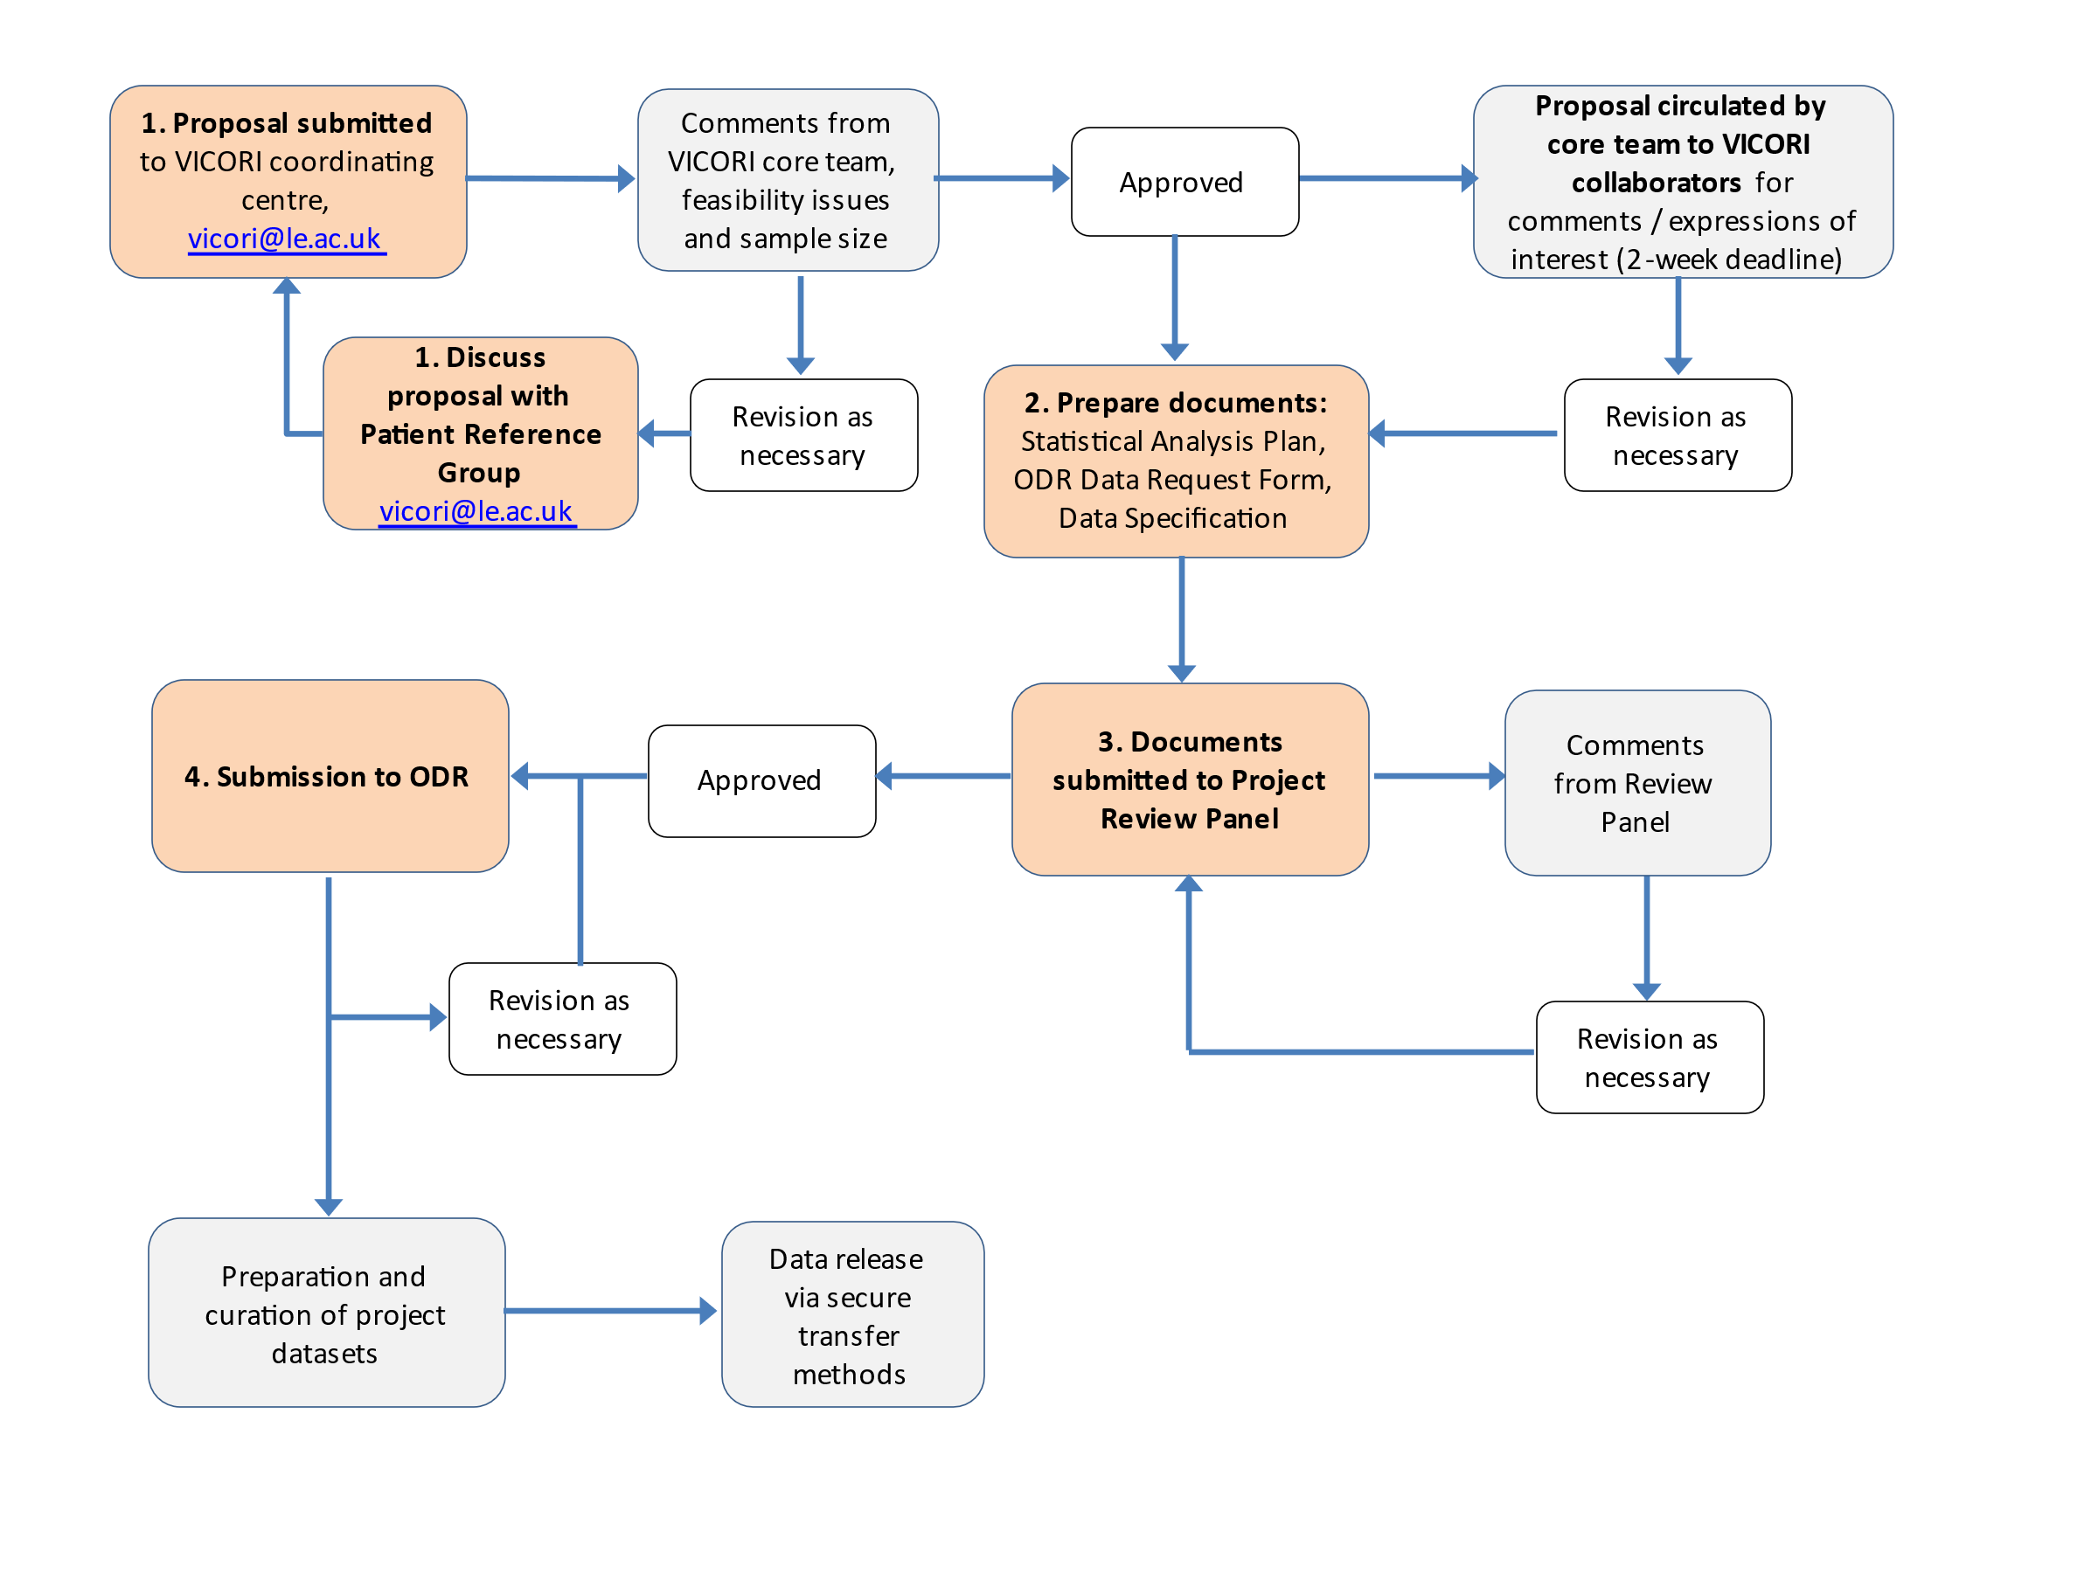
Figure 1. VICORI project proposal and data access flow diagram
Step 1: Submit Project Proposal
Researchers should first write a project proposal, following the Project Proposal template provided by the coordinating centre (VICORI_Project_Proposal.docx) and including the following headings:
Project title
Name of proposer
Background and scientific rationale
Research question and aim
Main exposures and outcomes
Relevant references
Analytical capacity
Once completed this form should be sent to the VICORI coordinating centre using the email vicori@le.ac.uk. The project proposal should also identify key project team members, for example who will lead the project and analyse the data, as well as working group members. Researchers should also specify the data sources required, outcomes, exposures, confounders and control population. The VICORI team will then work with the proposer to identify any feasibility issues, and provide approximate sample sizes.
The VICORI research programme adopts the data stewardship principle set out in the September 2021 Report: Participatory data stewardship | Ada Lovelace Institute
That report proposes data stewardship as the responsible use, collection and management of data in a participatory and rights-preserving way, informed by values and engaging with questions of fairness…..
Once the VICORI core team has given its feedback as to feasibility and sample size, researchers should engage with the VICORI Patient Reference Group (PRG) by a virtual meeting. Researchers can then openly discuss the research proposal with patients who have experienced cancer or heart disease, or both. Researchers should prepare a short slide set and brief plain English summary to send to the PRG before the virtual meeting - using the email vicori@le.ac.uk. A patient coordinator from the reference group will respond.
Once the PRG discussion has happened researchers should send the amended Project Proposal Template to the coordinating centre. Amendments to the Project Proposal Template will include proposal adjustments following the VICORI team and the PRG comments. Researchers will have discussed any ongoing project team collaboration from the patient reference group
A final project can then be discussed and agreed with the VICORI team.
Step 2: Prepare documents
Any analyses requiring VICORI data need to follow PHE data access procedures, which is managed by the Office for Data Release (ODR). The VICORI team can provide a VICORI specific, partly pre-filled ODR form and assistance in completing the form. In addition to an ODR form, researchers should also prepare a more detailed statistical analysis plan (SAP). Finally, researchers should select which variables they wish to extract and create a data specification document using NICOR and NCRAS data dictionaries.
In parallel, the VICORI coordinating team will circulate the Project Proposal to all VICORI collaborators (who wish to be informed of VICORI proposals), allowing collaborators 2-weeks to provide comments on the proposal and expressions of interest to join the working group.
Step 3: Documents submitted to Project Review Panel
Once all the required documents are ready and comments have been received from VICORI collaborators, the documents will be sent to a Project Review Panel for feedback and suggestions for any revisions before submission to the ODR. The review panel will ensure project proposals are:
- Achievable
- Deliverable
- Sufficiently distinct from other work package aims and known proposals
- Scientifically rigorous
- Methodologically rigorous, including the design and statistical approach
- Have a clinically relevant purpose
The review panel will provide advice where limitations and / or methodological issues arise and suggest any revisions before submission to ODR.

Step 4: Submission to ODR
Once approved by the Project Review Panel, the proposer along with help from the coordinating centre will then submit the Proposal with accompanying relevant documents to the Office for Data Release (ODR) at odr@phe.gov.uk. The ODR will review and provide feedback on the project proposal and data specification, which may will facilitate further revision.
The ODR’s responsibilities are to ensure lawful and legitimate data sharing with correct contractual controls and data confidentiality and anonymization standards. They abide by data minimisation techniques to ensure the minimum number of variables required for the analysis are released. There may be some privacy by design applied to variables, for example partial data removal (dates will be supplied as month and year only, event intervals will be derived between two dates instead of providing dates themselves) and masking (Provider, Consultant, GP Practice codes will be pseudonymised by default. Project-specific individual pseudo IDs will be released. Once approved a Data Sharing Contract will be drawn-up between PHE (the Data Controller) and the academic institution(s) who will receive the data (the Data Recipient(s)).

Step 5: Preparation and release of data
Once ODR have approved the project, the VICORI Analyst Team, who hold honorary PHE contracts, will prepare, curate and release the data while in dialogue with the project lead.
The VICORI Analyst Team (from Biostatistics Group, University of Leicester) work within PHE to help curate datasets for projects and can also assist with statistical / analytical support where needed, such as survival analysis (including relative and flexible parametric survival methods), multistate (comorbidity) modelling, competing risks, missing data, risk prediction and risk communication. External support may also be available from NCRAS / NICOR specialists.
The final analysis dataset will be released via the ODR using a secure file transfer.
All manuscripts are sent to the patient reference group before publication submission to allow feedback.

